**Linux Documentation:**

In windows we use OS for operate all the functions and communicate with hardware, in same way in Linux kernel will do same as OS

In Linux folder called as Directory

Windows (administrator)= Linux (root user)

Windows (File) = Linux (file)

Windows (software) = Linux (package)

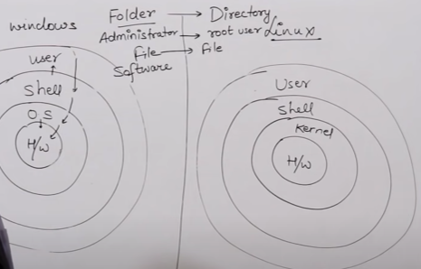

**File system Hierarchy:**

1. In windows we have default C drive with backward \
2. In Linux we have forward slash (/)

**Window file system in C drive:**

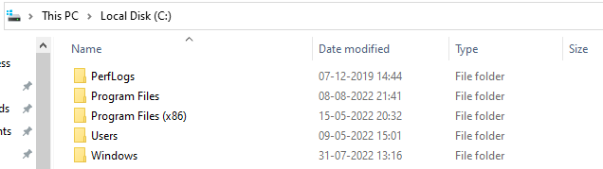

**Differences between Linux & Windows file hierarchy:**

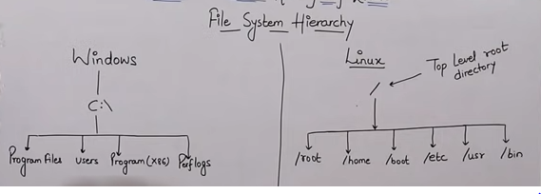

**Detailed about each directory which are main in Linux:**

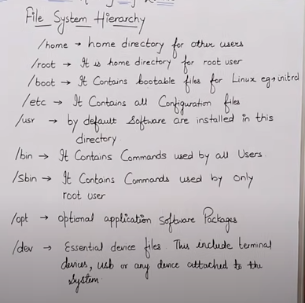

When user profile not created on the machine it goes to admin profile in windows same way in Linux it goes to root.

**Root**: if user not yet created then it defaults takes root user

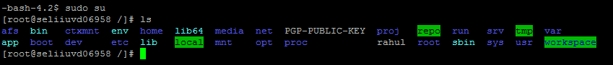

**Home**: it is used for other user mean once we can user profile and all the information can save on home folder

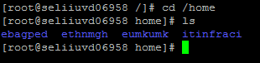

**Boot**: To run machine required files in this boot folder, like POST prosses

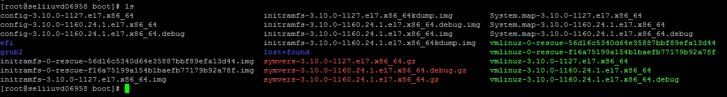

**etc**: all configuration files it has, if we know about hardware configuration about machine

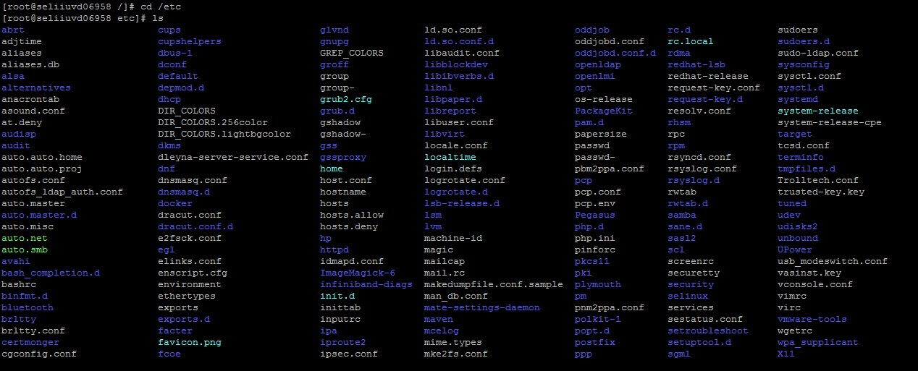

**Usr:** All the software’s install in the user directory or opt directory

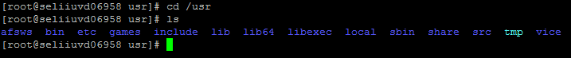

**bin**: it contains commands which were used by all users

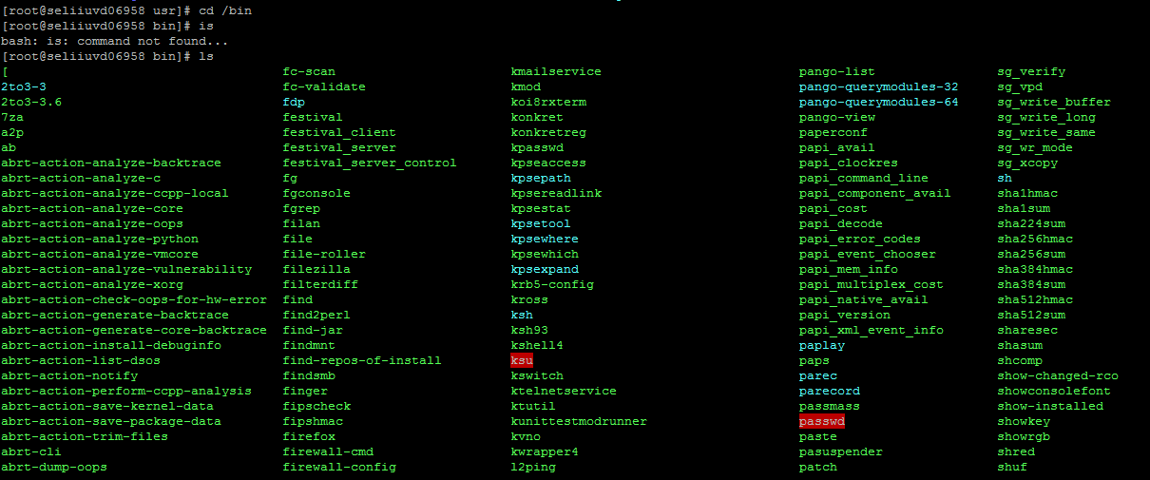

**sbin:** it contains commands of root user

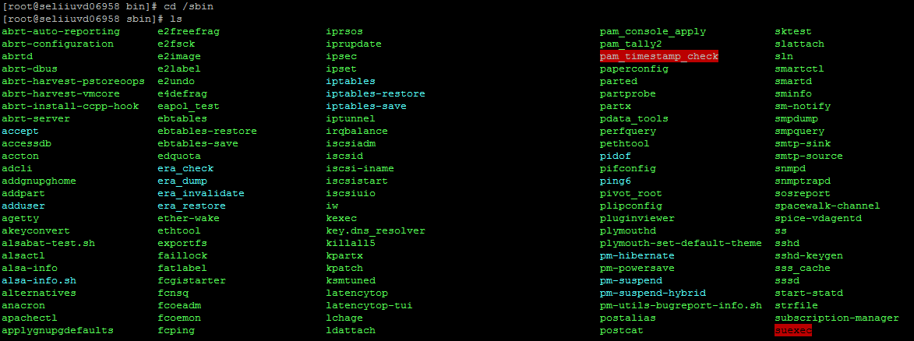

**Dev:** this is for essential device files, USB terminal or any device which attached to the machine

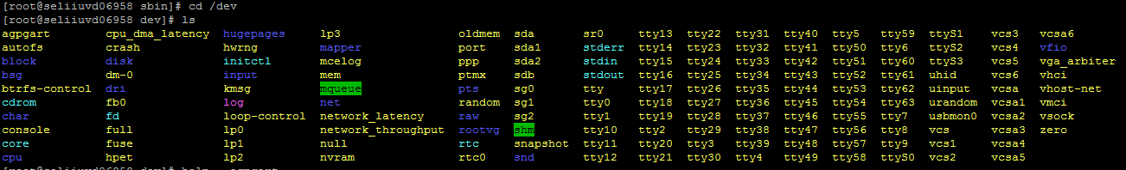

**Create file:**

We have 4 ways for create file on Linux.

**cat**

**touch**

**vi/vim**

**nano**

**Cat**:

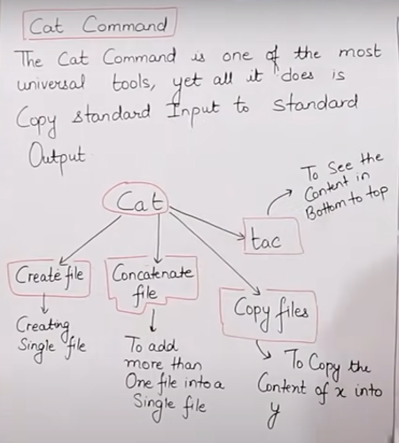

**For create file with text**



(For save this file Ctrl+d )

**Output of saved file:**

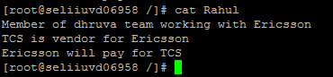

**If you want to add some text to existing file**

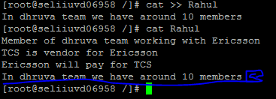

* **Cat can combine all the files into one file**

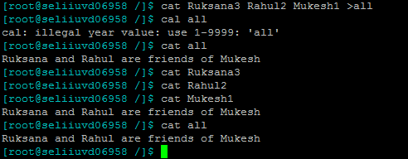

**Cat use for copy the one file data to another file but it over write on the existing data.**

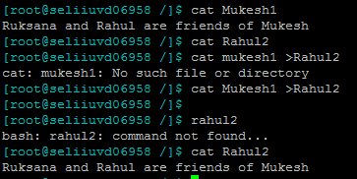

**Touch**: For create multi empty files

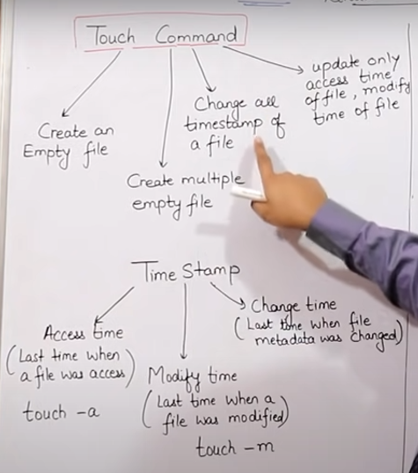

**Command:** **$ touch file1 file2 file3 file4**

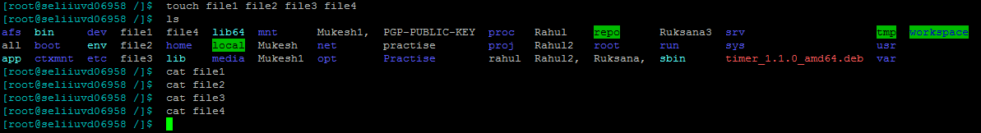

* With touch we can see the file access time and Modified time

**Command:**

**$ stat file1 ( to see the access time, modified time , database change time )**

**$ touch -a file1 ( to change the access time )**

**$ touch -m file1 (To change the modified time )**

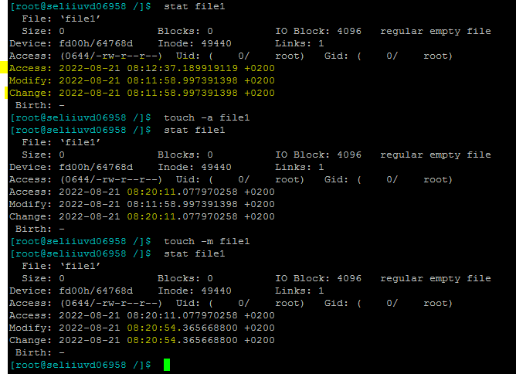

**Vi/vim, Nano** : For create and edit the file

**Command:**

**$ vi file 8 ( to create file )**

**Give that name and click enter then press “ i ” to insert text in the file after enter text press “shift+semi colon “ then press ESC then write “wq” for save and comeout from the edit mode**

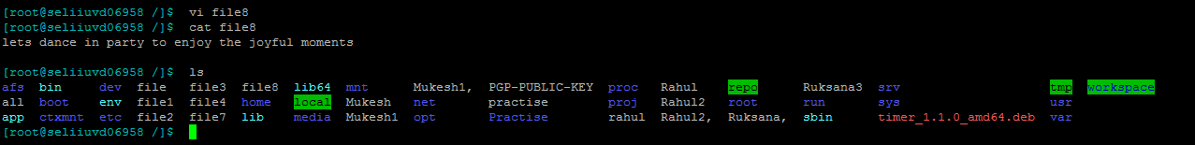

**For editing again login into the file and enter the text follow the same process**

**$ vi file8 and enter I next using navigation key come down and enter the text**

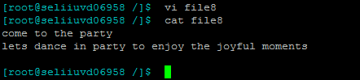

**Nano:**

**Command: $ nano file9**

**Enter the text what you want to save in this file then Ctrl+x to comeout and for save shift+y and click enter**

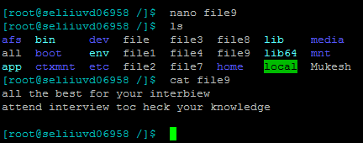

**Additional commands: ls – l & ll : for see the all files detailed information like file or directory and when it was last used . ls -a for it shows hidden files also (hidden files start with dot )**

**Ls -a:**



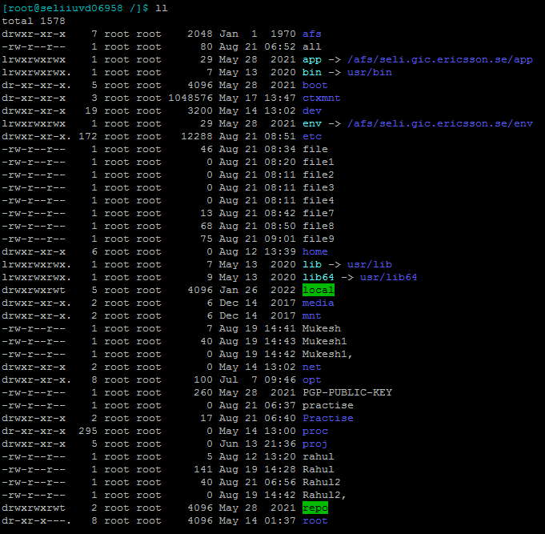

**For create hidden file or directory we need to add dot in front of file or directory name**

**Command:**

**$ cat .file11 (or )$ touch .file10 (or ) $ vi .file12 (or ) nano .file13**

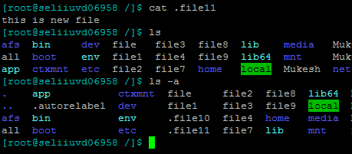

**Directory (Folder ):**

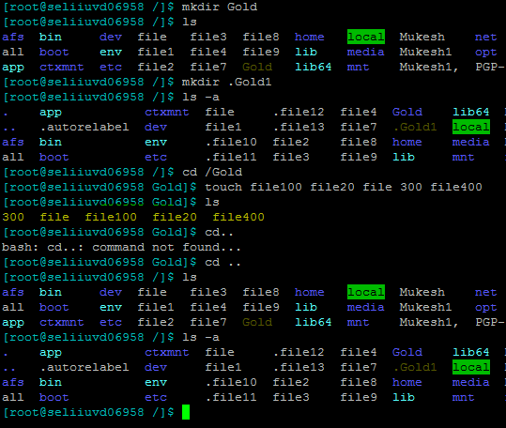

if you want to create multiple directories at a time we can do

**$mkdir dir2 dir3 dir4**

Come out from the one directory we use

cd ..

if you want to come out from 3 dir

cd../../..

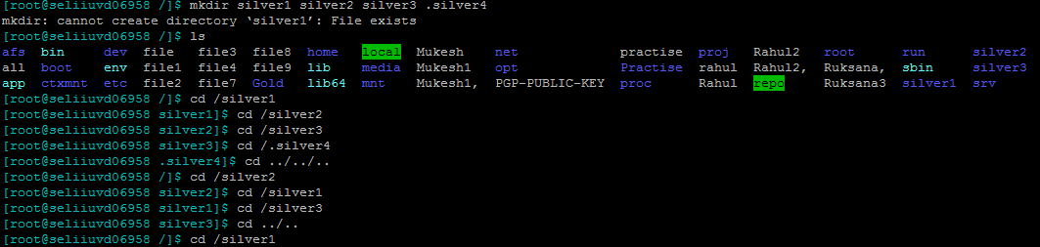

where we are will get to know by using

#pwd

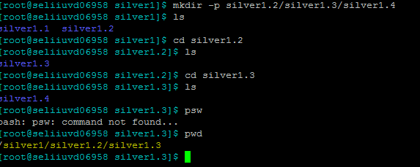

**We can enter final directory using below command**

**Command:** $ cd silver5/silver6/silver7

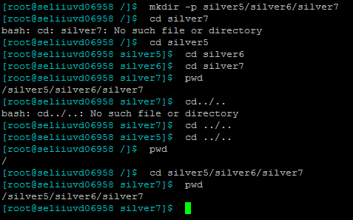

**Copy:** To copy one file to another file

( cp source file1 destination file2 )

**Command:** **$ cp file1 file2**

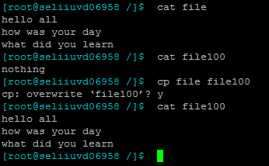

**if you want to move or cut and paste the file**

**command :** **$ mv file1 dir1**

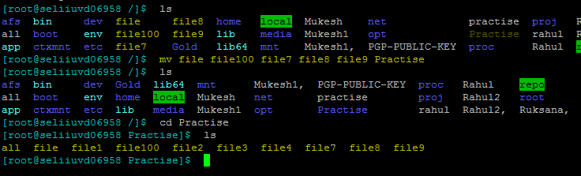

**To remove file or dir “ rm “ need to use**

**rmdir** for remove directory

**rmdir -p** to remove parent directory

**rmdir -pv** all directories need to remove at a time

**rm -rf** removes even non-empty files and directory forcefully

**rm -rp** removed non-empty directory including parent & subdirectory

**rm -r** for remove empty directory

**ls -l** gives full detailed information about files and directory and permissions

in this output if we can see started with **dr** it means its directory, if we see - then it is file

**cntl +l** for clear

**ls -al** for detailed about hidden and all the files and directories detailed information

cat >>fie1 with this we can edit file1

head file

less file55

more file55

tail file55

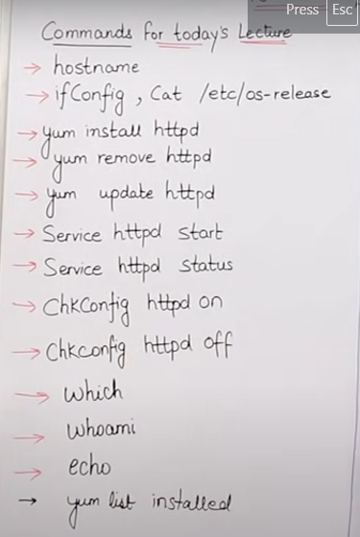

**hostname:** To know about machine name

**ifconfig:** To know about ip address, subnet, broadcast, gateway, mac address

**hostname -i :** To know only Ip address Ip address

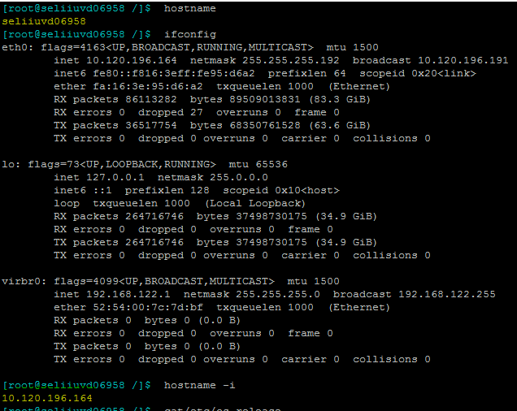

**cat /etc/os-release:** to know which operating system details

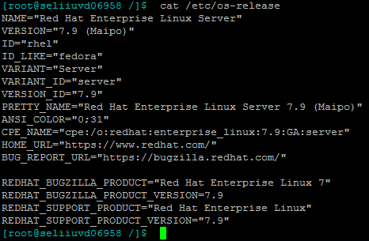

**yum:** this is used for update, install, remove

**yum install httpd:** to install apache files by default install

**yum install httpd -y :** it install all the apache files without aking permission multiple times

**yum remove httpd:** to remove the apache files

**yum update httpd:** to update

**service httpd start:** To start services

**service httpd status:** To know the status

**chkconfig httpd on:** service will not start again after start machine, it appears by default

**chkconfig httpd off:**

**which:** To know the software installed or not ( which Nosql booster )

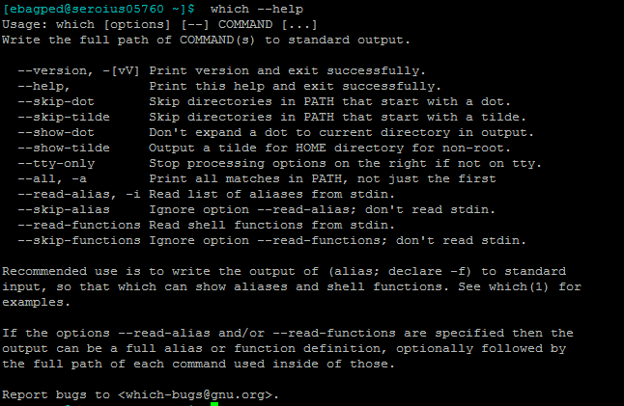

**whoami:** to know who are you, like normal user or root user, user name

**yum list installed:** all the packages list which were installed

**echo :** use for show message to other user who was log in into same machine



**Example:** echo "Hey Mukesh"

we can create file also using this echo

**echo "all learners are active " >file 4**

if you want to add some text to existing one follow same process how we do use cat command

**example:** **echo" august 15th in india indepence day '>> file4**

if you want to empty the file then we can run below command

echo >file 4

**grep:** for ctlt +F

**sort:** list of content will be arranged in alphabetic

**yum update -y :** for update all files which are installed on the machine

**tree:** for know the structure of all directories

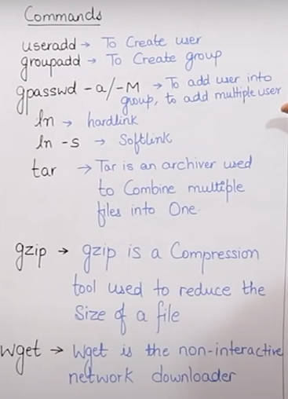

**Useradd:** To create user

Exam: #useradd Rahul

# cat /etc/passwd

we can see the user name at bottom

**groupadd:** To create group

exa: #groupadd provisioning

#cat /etc/group

**gpasswd -a/-M :** to add user into group, to add multiple user

exa: #gpasswd -a mukesh provisioning

#passwd -M ruksana,mukesh,rahul provisioning

**ln:** for create hard link (backup )

#ln file2 backupfile2

#ls

even if you delete file2 it keeps hardlink file

if you want to add something in this file, it will reflect on backup file also

**ln -s:** for soft link

exa: #ln -s file1 softfile1

#ls -l

**tar:** this is used for to combine multiple files into one

Exam: #tar -cvf dirAtar dirx

( c= create , v= verbrase, f= Forcefully )

#ls

will get dirA tar dirx

**gzip:**

exam: #gzip dirxA tar

#ls

will get dirA tar gz

for unzip this we do like below

**#unzip dirA tar z**

#ls

**#dirA tar**

for extract this unzip file

**#tar -xvf dirA tar**

#ls

will get dirx

**wget:** non-interactive network downloader

exam: #wget <URL>

* **if started with “ l ” this represents link**
* **dr = directory**
* **- = file**

**Permissions:**

**Information about the output of ls -l command.**

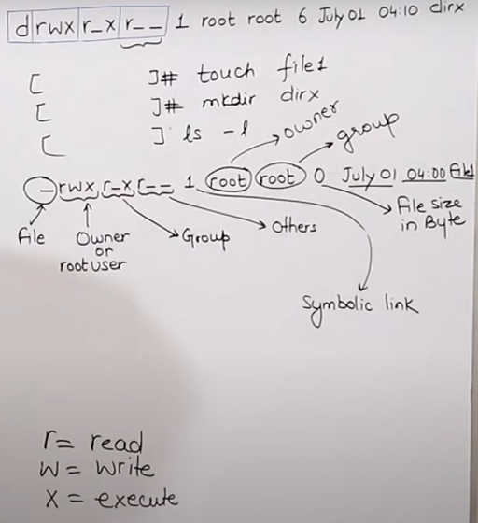

In directory we have 2 symbolic links where we can see 1 in file.

* R= 4, w=2, x=1, - = 0

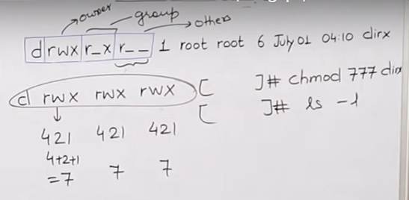

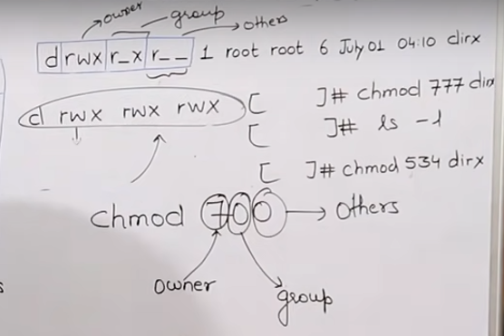

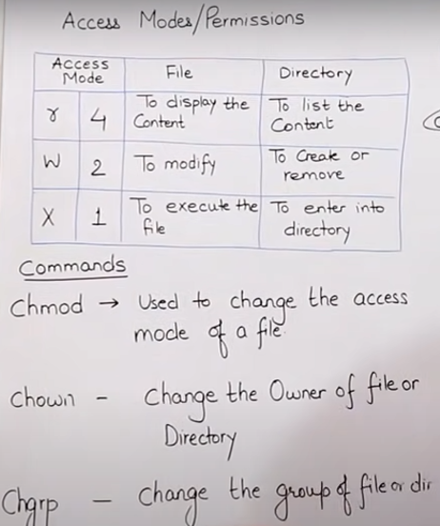

* We can do it in another way also, in this we use =, +, -

**U= user**

**g=group**

**o=others**

**u=rwx** (add read write execute permission to user)

**u+w** (add write permission to user)

**g+r** (add read permission to group)

**o-x** (remove execute permission to others)



If you write like this, the existing permissions will update as per the instructions

(Add read permission to user, add read write execute permission to group, add write execute permission to others)

Example: chmod u-wx,g+w,o=wx file1

**Chmod:** To change the access of the file

**Chown:** To change the owner of the file

**Chgrp:** to change the group name

